Software Requirement Specifications
Quiz app



Submitted by
Tanzeel Ur Rehman (S23BINFT1M01099)

Submitted to
Mr. Suleman Shah

Department of Information Technology
Faculty of Computing
The Islamia University of Bahawalpur

Meeting Details
Sr No | Details | Date | Supervisor Signature
Summary
The Software Requirements Specification (SRS) for the "Quiz App for Students," a mobile learning application that uses interactive quizzes to assess and enhance students' knowledge, is presented in this document. The system's goal is to give students an easy-to-use platform where they can sign up and log in, take subject-specific multiple-choice tests, and get immediate feedback and score. Key functional needs, including quiz categories, timer-based quizzes, result creation, performance tracking, and a scoreboard system to encourage consistent learning, are identified in the document. Additionally, it contains the integration needs for Firebase for database administration and authentication, Flutter as the development framework, and the OpenAI API for AI-based question generating. To guarantee the seamless and secure operation of the program, non-functional needs like usability, security, performance, and dependability are also emphasized.

Table of Contents
1. Introduction 5
1.1. Purpose 6
1.2. Scope 6
1.3. Product Perspective 6
1.4. User Characteristics 6
1.5. Similar apps and systems/Literature Review 7
1.6. Proposed Technologies 7
2. Requirements 8
2.1. Function Requirements 8
2.1.1. Sign Up 8
2.1.2. Login 8
2.1.3. View Quiz catagories 8
2.1.4. Start Quiz 8
2.1.5. Attempt Quiz 9
2.1.6. Time Based Quiz 9
2.1.7. Submit Quiz 9
2.1.8. Calculate Score 9
2.1.9. Show Result 10
2.1.10. Save Attempt 10
2.1.11. Leaderboard 10
2.1.12. Ai quiz generation 10
2.2. Non-Functional Requirements 11
2.2.1 Performance requirements 11
2.2.2 Compatibility 11
2.2.3 Security requirements 11
2.2.4 Usability requirements 11
2.2.5 Maintainability 11
2.2.6 Reliability 11
3. Use Cases and Flow of Processes 12
3.1. Use Case 1 13
3.2. Use Case 2 15
3.3. Use Case 3 16
3.4. Use Case 4 17
3.5. Use Case 5 18
3.6. Use Case 6 19
3.7. Use Case 7 20
3.8. Use Case 8 21
4. References 22

- Introduction
  - Purpose
The purpose of the Quiz App for Students is to provide an interactive and easy-to-use mobile platform where students can practice multiple-choice quizzes, check their knowledge, and improve learning through a self-paced system. The app helps students by offering different quiz categories/subjects, timer-based attempts, instant scoring and feedback, and performance tracking so they can identify weak areas and improve over time. It also aims to keep students motivated through features like a leaderboard and supports modern learning by enabling AI-based quiz question generation for continuous and updated practice material.
  - Scope
The Quiz App for Students is a Flutter-based mobile application designed to help students learn and assess their knowledge through interactive multiple-choice quizzes. The scope of the system includes user registration and login using Firebase Authentication, a collection of quizzes organized into multiple categories/subjects, and a timer-based quiz attempt mechanism. After each quiz, the application will provide instant results including score, correct/incorrect answers, and feedback, and it will store the attempt data in Firebase Database for progress and performance tracking. The app will also include a leaderboard feature to display top-performing users and encourage regular learning. Additionally, the system will support AI-based quiz question generation using the OpenAI API, enabling the creation of new questions to keep quiz content updated and engaging. Future enhancements such as multiplayer quizzes and AI-based recommendations may be added later but are not mandatory for the initial release.
  - Product Perspective
The Quiz App for Students is a standalone mobile learning application developed using Flutter for cross-platform support (Android and potentially iOS). The app will work as a client application that connects to cloud services for core features. Firebase Authentication will handle secure user sign-up and login, while Firebase, Firestore Realtime Database will store quiz categories, questions, user attempts, scores, and leaderboard data. The app will also integrate with the OpenAI API to generate quiz questions (either directly or through an admin-controlled process). The system is designed to be scalable so new categories, questions, and features can be added in the future without major changes to the app structure.
  - User Characteristics
- Student / Regular User
  - Skill level: Basic smartphone usage (no technical knowledge required).
  - Goals: Practice quizzes, get instant feedback, improve knowledge, track progress, and compare performance on leaderboard.
  - Usage frequency: Can range from occasional (exam preparation) to daily practice.
  - Access needs: Simple UI, clear navigation, readable questions, quick results, and reliable performance tracking.
- Admin (Optional)
  - Skill level: Basic app/content management understanding.
  - Goals: Manage categories and question bank, monitor content quality, and control AI-generated questions (generate, review, approve).
  - Usage frequency: Less frequent than students; mostly when updating content or maintaining system quality.
  - Access needs: Secure/admin-only access, easy tools for adding/editing questions and categories, and moderation controls for AI questions.

  - Similar apps and systems/Literature Review
Many existing quiz and learning applications show that quizzes improve retention through active recall, instant feedback, and repeated practice. Popular systems such as Google Forms/Quiz, Kahoot!, Quizizz, and Duolingo-style practice modules provide features like MCQ-based testing, timed sessions, scoring, progress tracking, and competitive elements (leaderboards). These systems demonstrate that gamification (points, rankings, badges) increases student motivation and engagement. Research and practice in e-learning also emphasize that self-paced quizzes help students identify weak areas and improve performance over time using continuous assessment. Based on these concepts, the proposed Quiz App adopts core learning features such as categorized quizzes, timer-based attempts, instant results, and performance history, while also introducing AI-based question generation to keep content updated and reduce manual effort.
  - Proposed Technologies
- Flutter
- Firebase Authentication
- Firebase Firestore (or Realtime Database)
- OpenAI API

- Requirements
  - Function Requirements
    - Sign Up
Name: FR001
Purpose: Sign up process is required for a student to become a registered member of the Quiz App system.
User(s): Student/User
Input:
Full Name: Actual name of the student.
Email: Valid email address (must be unique in the system).
Password: Must be at least 8 characters long (should include at least 1 number).
Roll No (Optional): Student roll number for academic identification.
Display Picture (Optional): Latest profile picture (face photo).
Output: User account is created successfully and the user becomes a member of the system and can log in.
    - Login
Name: FR002
Purpose: Login is required to authenticate a registered user and provide access to the app features.
User(s): Student/User, Admin (if admin module exists)
Email: Registered email address.
Password: Registered password.
Output: User is authenticated and redirected to the home/dashboard screen.
    - View Quiz catagories
Name: FR003
Purpose: To allow users to browse available quiz subjects/categories.
User(s): Student/User
Input:
User Request: Open categories screen / home screen.
Output: Categories list is displayed (e.g., English, Math, Computer, etc.).
    - Start Quiz
Name: FR004
Purpose: To allow the user to begin a quiz from a selected category.
User(s): Student/User
Input:
Category Selection: Selected quiz category/subject.
Quiz Settings (System-defined): Number of questions and quiz duration (timer).
Output: Quiz session starts and first question is shown with the timer.
    - Attempt Quiz
Name: FR005
Purpose: To allow the user to attempt MCQ questions during an active quiz.
User(s): Student/User
Input:
Selected Option: One option per question.
Navigation Action: Next (and Previous if enabled).
Output: User answers are saved for the current quiz session and the next/selected question is displayed.
    - Time Based Quiz
Name: FR006
Purpose: To ensure the quiz is completed within a fixed time limit.
User(s): Student/User (System controls timer)
Input:
Quiz Duration: Time limit set by system for the quiz.
Output: Remaining time is displayed; on time completion the quiz is automatically submitted.
    - Submit Quiz
Name: FR007
Purpose: To submit the quiz and calculate the result based on correct answers.
User(s): Student/User, System (auto-submit on timer end)
Input:
Submit Action: User presses submit OR timer ends.
User Answers: Selected options for each question.
Output: Quiz is submitted and score is calculated (correct, wrong, total score).
    - Calculate Score
Name: FR008
Purpose: To provide instant result and learning feedback after quiz completion.
User(s): Student/User
Input:
Quiz Attempt Record: Calculated score and answer comparison.
Output: Result screen showing score, correct/incorrect answers, and correct answers for review.
    - Show Result
Name: FR009
Purpose: To store quiz attempts and allow the user to track performance over time.
User(s): Student/User (System stores data)
Input:
Attempt Details: UserId, category, score, correct/wrong count, date/time, duration.
Output: Attempt is saved in database and user can view history/performance summary.
    - Save Attempt
Name: FR010
Purpose: Leaderboard is required to motivate students by showing rankings based on quiz performance.
User(s): Student/User
Input:
Leaderboard Rule (System-defined): Ranking criteria such as total points, highest score, or average score (as configured).
User Attempt Data: Scores/points saved after quizzes.
User Request: Open Leaderboard screen.
Output:
A ranked list of top users is displayed (e.g., Rank, Display Name, Points/Score).
Leaderboard updates after each completed quiz attempt.
    - Leaderboard
Name: FR011
Purpose: AI-based question generation is required to create new quiz questions automatically to keep content updated and reduce manual effort.
User(s): Admin (recommended), System
Input:
Category/Topic: Selected subject/topic for which questions are needed.
Difficulty Level (Optional): Easy/Medium/Hard (if supported).
Number of Questions: How many MCQs to generate.
AI Prompt/Instructions (System-defined): Required format (question statement, 4 options, correct option).
OpenAI API Key/Access: Valid API configuration (handled securely).
Output:
MCQ questions are generated in the required format.
Generated questions are saved in the database as Draft/Pending Approval (recommended) or directly published (if configured).
    - Ai quiz generation
Name: FR012
Purpose: Approval is required to ensure AI-generated questions are correct, relevant, and appropriate before students use them.
User(s): Admin
Input:
Draft AI Questions: Questions generated by OpenAI and stored as pending.
Admin Action: Approve / Reject / Edit question content and correct answer.
Output:
Approved questions become available for quizzes in the selected category.
Rejected questions remain unpublished or are deleted/returned for regeneration.
  - Non-Functional Requirements

2.2.1 Performance requirements
The system shall load main screens (Home/Categories) within 3 seconds under normal network conditions. Quiz questions shall load within 2 seconds after starting a quiz (depending on internet speed). The app shall respond quickly to taps (next, select option, submit) without noticeable delay. Performance should remain stable as users and questions increase.

2.2.2 Compatibility
The application shall run on common Android devices (minimum Android version to be defined, e.g., 8.0+). The UI shall adjust properly to different screen sizes and resolutions. The system shall work on both portrait and (if required) landscape orientations. Flutter-based design shall ensure consistent behavior across supported devices.

2.2.3 Security requirements
The system shall use Firebase Authentication for secure user registration and login. User data in the database shall be protected using Firebase Security Rules. Sensitive information such as passwords shall never be stored in plain text, and emails should not be publicly shown on the leaderboard. The OpenAI API key shall be secured and not exposed directly in client-side code.

2.2.4 Usability requirements
The app shall provide a simple and user-friendly interface suitable for students with basic mobile knowledge. Navigation shall be clear (Home, Categories, Quiz, Results, History, Leaderboard). Text, buttons, and quiz options shall be readable and understandable. The system shall minimize steps required to start and complete a quiz.

2.2.5 Maintainability
The system shall be developed using a modular and organized code structure to support future updates. It should be easy to add new categories and questions through the database without changing the app code. The system shall support fixing bugs and adding features without affecting existing functions. Code should be documented to help future developers understand the project.

2.2.6 Reliability
The system shall ensure correct scoring by accurately matching selected answers with stored correct answers. Quiz attempts and results shall not be lost during normal use. If an error occurs during submission, the system should allow retry to avoid losing progress. The system shall handle unexpected events (e.g., app minimized) without corrupting the quiz session.

- Use Cases and Flow of Processes
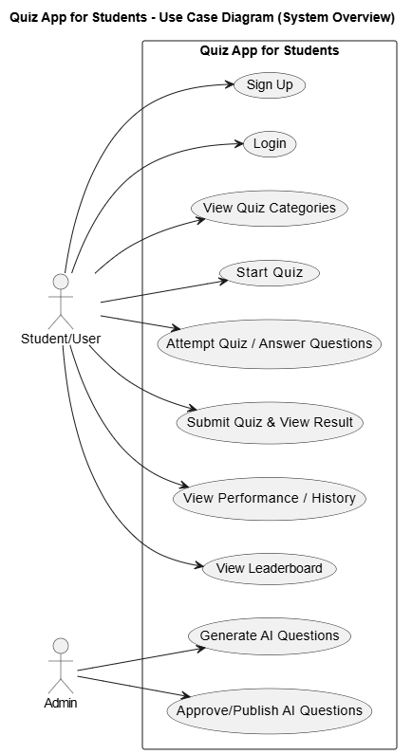

  - Use Case 1
Field | Details
ID | UC001
Name | Sign Up
Description | This use case describes the process flow of Sign Up for a new student user.
Requirement(s) | FR001
Actor(s) | Student/User
Precondition | Actor must not already be registered in the Quiz App system. Actor must have internet access.
Postcondition | Actor account is created successfully and the actor becomes a registered member of the system (and can log in).
Basic Flow
- Actor opens the Quiz App and selects Sign Up.
- Actor enters required credentials.
- System validates the inputs.
3.1 Following fields are required:
3.1.1 Full Name
3.1.2 Email
3.1.3 Password
3.2 System checks proper inputs for the following:
3.2.1 Email format must be valid
3.2.2 Password must be at least 8 characters and include at least 1 number
- On successful validation, the system creates a new user account using Firebase Authentication.
- System stores basic user profile in the database.
- System displays success message and redirects the actor to Home/Dashboard (or Login if required).
Alternative Flow
- Actor chooses Login instead of Sign Up (if already registered).
- System performs Login use case (UC002).
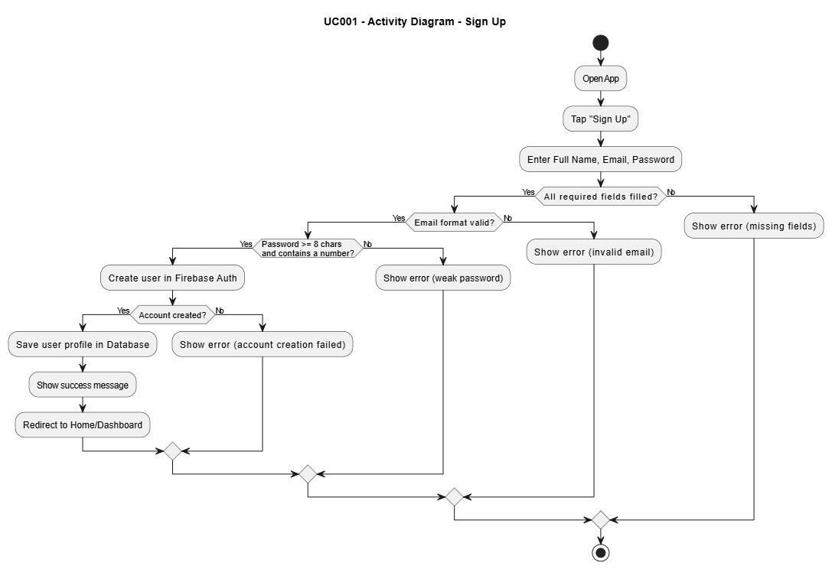

Use Case 2

Field | Details
ID | UC002
Name | Login
Description | This use case describes the process flow of user login to access the Quiz App.
Requirement(s) | FR002
Actor(s) | Student/User
Precondition | Actor must be a registered member of the system and must have internet access.
Postcondition | Actor is authenticated successfully and redirected to the Home/Dashboard screen.
Basic Flow
- Actor opens the Quiz App and selects Login.
- Actor enters credentials.
- System validates the inputs.
3.1 Following fields are required:
3.1.1 Email
3.1.2 Password
3.2 System checks proper inputs for the following:
3.2.1 Email format must be valid
- System sends login request to Firebase Authentication.
- On successful authentication, system loads user profile and displays Home/Dashboard.
Alternative Flow
- Actor selects Forgot Password.
- System starts password reset process (optional separate use case).

Use Case 3
Field | Details
ID | UC003
Name | View Quiz Categories
Description | This use case describes how the user views available quiz categories/subjects.
Requirement(s) | FR003
Actor(s) | Student/User
Precondition | Actor must be logged in. Categories must exist in the database.
Postcondition | Actor can view the list of quiz categories and select one category.
Basic Flow
- Actor opens the Home/Dashboard screen.
- System requests quiz categories from the database.
- System displays categories list (e.g., Math, English, Computer).
- Actor selects a category.
Alternative Flow
- System loads cached categories (optional) if network is slow.

Use Case 4
Field | Details
ID | UC004
Name | Start Quiz
Description | This use case describes the process of starting a quiz after selecting a category.
Requirement(s) | FR004, FR006
Actor(s) | Student/User
Precondition | Actor must be logged in. Actor must have selected a category. Questions must exist for that category.
Postcondition | Quiz session starts, timer begins, and the first question is displayed.
Basic Flow
- Actor selects a category and taps Start Quiz.
- System fetches questions for the selected category from the database.
- System validates that sufficient questions are available.
- System creates a new quiz session/attempt.
- System starts the quiz timer.
- System displays the first MCQ question with options.
Alternative Flow
- If quiz settings allow, system randomizes questions before showing them.
Exceptions
- Insufficient Questions: System displays “Not enough questions available” and stops quiz start.
- System unable to respond / Network Error: System shows error and provides retry.

Use Case 5
Field | Details
ID | UC005
Name | Attempt Quiz (Answer Questions)
Description | This use case describes how the user answers MCQ questions during an active quiz.
Requirement(s) | FR005
Actor(s) | Student/User
Precondition | Quiz session must be active and timer running. Questions must be loaded.
Postcondition | Actor’s selected answers are saved for the quiz session and the quiz progresses question by question.
Basic Flow
- System displays a question with multiple options.
- Actor selects one option.
- System stores the selected option for that question.
- Actor taps Next to move to the next question.
- Steps 1–4 repeat until all questions are attempted or time ends.
Alternative Flow
- Actor uses Previous to review earlier question (if enabled).
- Actor changes selection before submission (if allowed).

Use Case 6
Field | Details
ID | UC006
Name | Submit Quiz & View Result
Description | This use case describes the quiz submission process and displaying results/feedback.
Requirement(s) | FR007, FR008, FR009
Actor(s) | Student/User, System (auto-submit)
Precondition | Quiz attempt must be active. User has attempted some/all questions OR timer has ended.
Postcondition | Quiz is submitted, score is calculated, results are shown, and attempt is saved in database.
Basic Flow
- Actor taps Submit Quiz OR timer reaches zero (auto-submit).
- System locks the quiz answers.
- System calculates score by comparing answers with correct options.
- System displays result summary (correct, wrong, total score/percentage).
- System shows correct answers for feedback/review.
- System saves quiz attempt record in the database.
- System updates performance summary and (if enabled) leaderboard points.
Alternative Flow
- If user submits early, system confirms submission (optional confirmation popup).
Exceptions
- Save Failed / Network Error: System shows message and retries saving; if retry fails, it may queue the result for later sync (optional).
- System unable to respond: System shows error and returns user to safe state.

Use Case 7
Field | Details
ID | UC007
Name | View Performance / History
Description | This use case describes how the user views previous attempts and performance summary.
Requirement(s) | FR009
Actor(s) | Student/User
Precondition | Actor must be logged in. Attempt history may exist in database.
Postcondition | Actor views performance history and summary metrics.
Basic Flow
- Actor opens Performance/History screen.
- System fetches user’s quiz attempts from database.
- System displays attempts list (date, category, score).
- System displays summary (average score, best score, category-wise progress).
Alternative Flow
- Actor filters history by category (optional).
Exceptions
- No Attempts Found: System shows “No quiz history available yet”.
- Network Error: System shows error and retry option.

3.8. Use Case 8
Field | Details
ID | UC008
Name | View Leaderboard
Description | This use case describes how the user views the leaderboard rankings.
Requirement(s) | FR010
Actor(s) | Student/User
Precondition | Actor must be logged in. Leaderboard data must exist.
Postcondition | Actor views the leaderboard list and rankings.
Basic Flow
- Actor opens Leaderboard screen.
- System fetches leaderboard records from database.
- System displays ranked list (rank, display name, points/score).
Alternative Flow
- System displays top N users (e.g., top 10/50) based on configuration.
Exceptions
- No Leaderboard Data: System shows “Leaderboard not available yet”.
- Network Error: System shows error and retry option.

- References
- Flutter, “Flutter documentation,” Google. [Online]. Available: https://docs.flutter.dev/. Accessed: Apr. 29, 2026.
- Firebase documentation [Online]. Available: https://firebase.google.com/docs.
- Firebase “Firebase authentication” [Online]. Available: https://firebase.google.com/docs/auth
- OpenAI, “OpenAI API documentation,” OpenAI. [Online]. Available: https://platform.openai.com/docs.

